NIOS Launch Step 1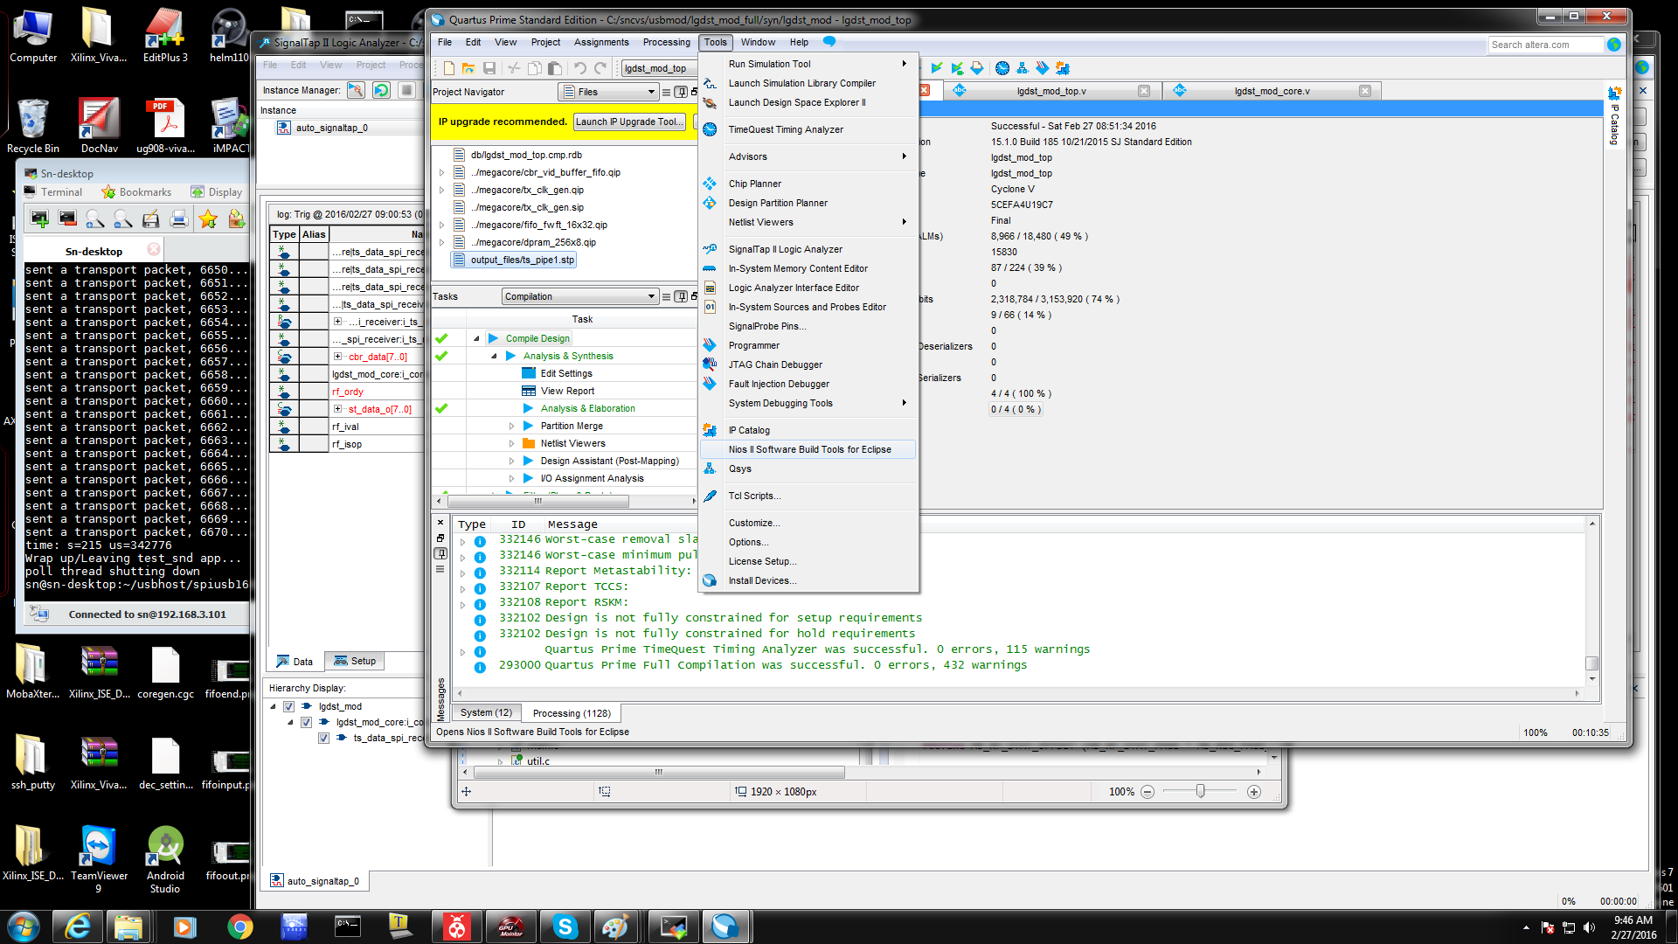

NIOS Launch Step 2 (Must change directory to local project directory ./syn)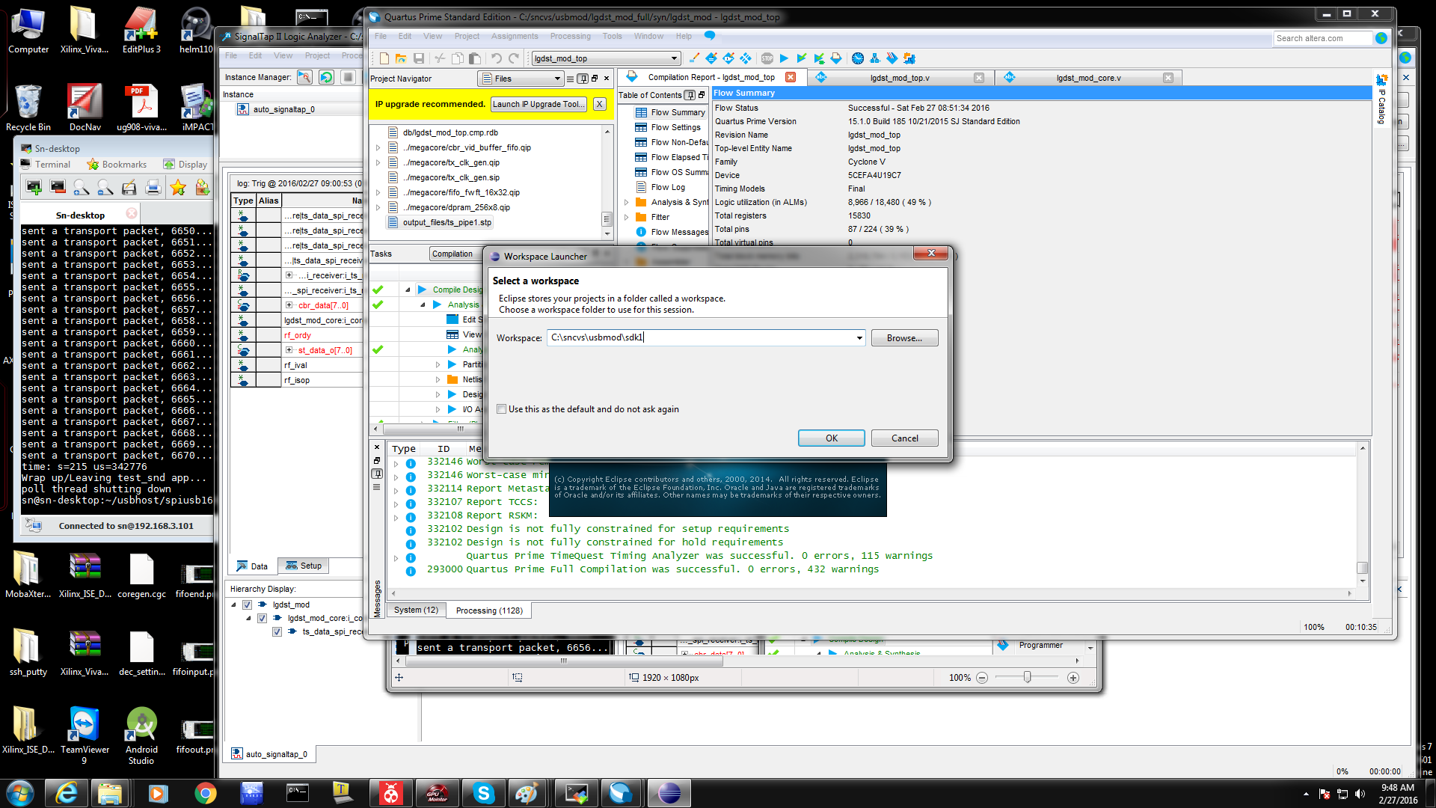

NIOS Launch Step 3 (Import) 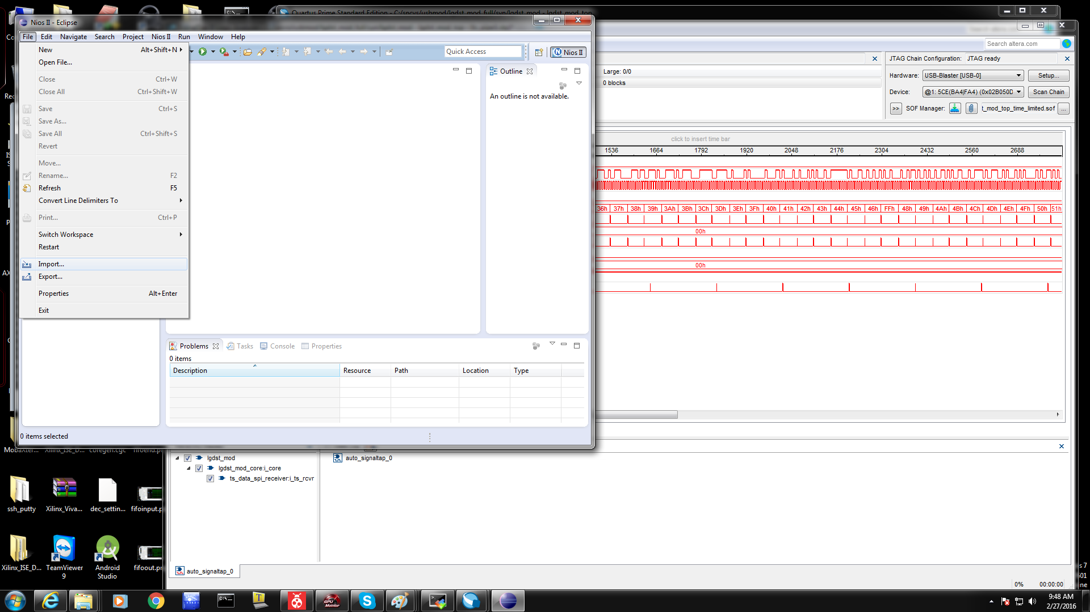

NIOS Launch Step 4 (Click Existing Projects into Workspace)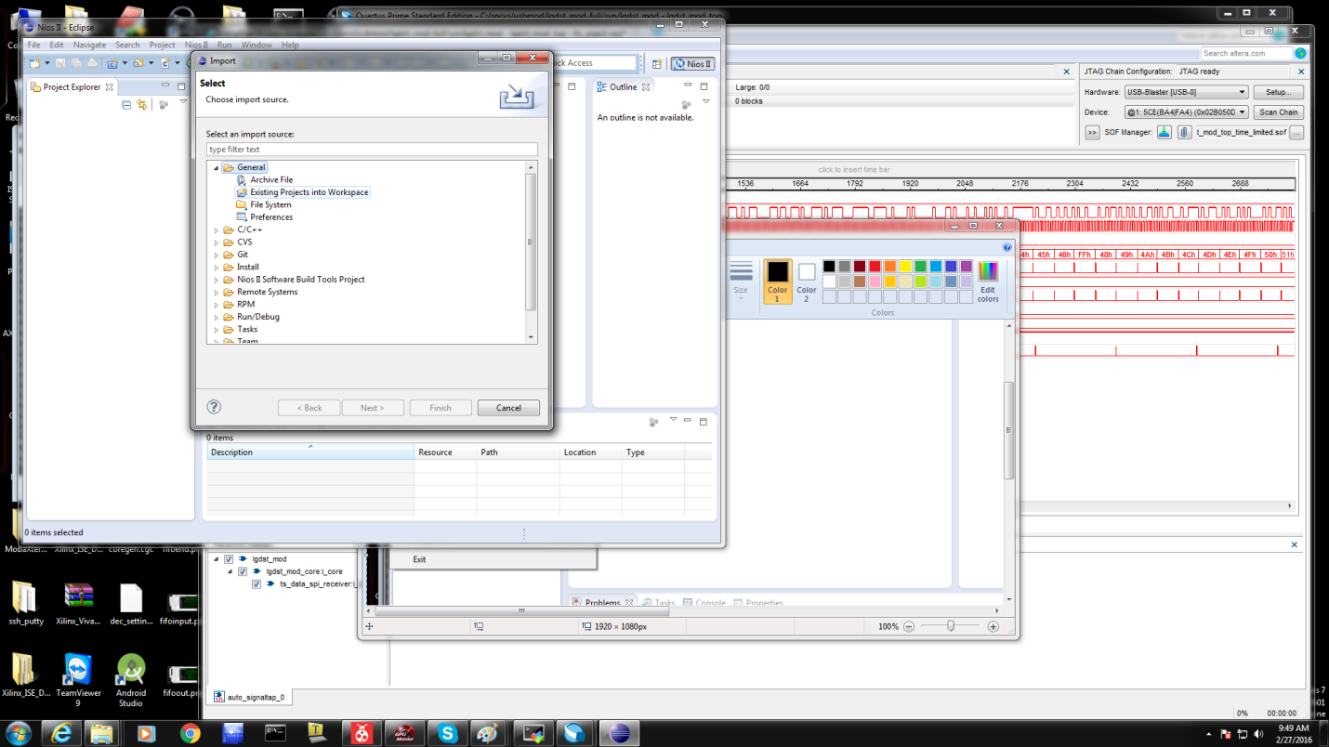

NIOS Launch Step 5 (Browse must select "local_project/syn/software" folder)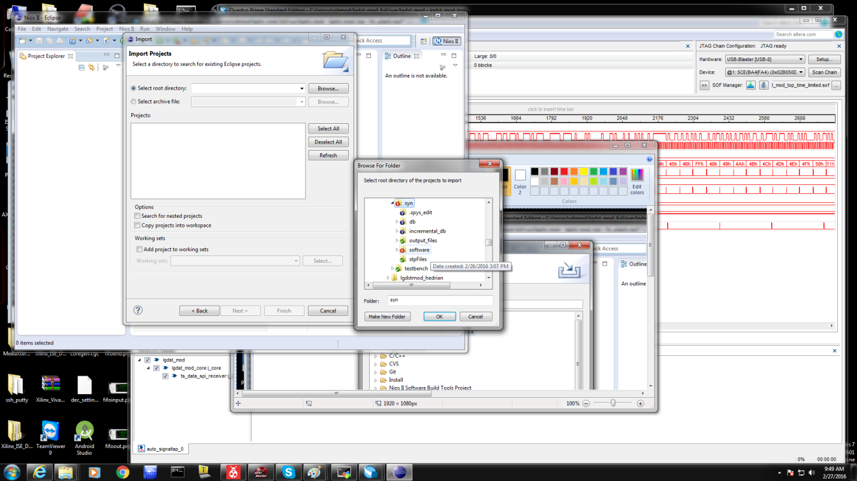

NIOS Launch Step 6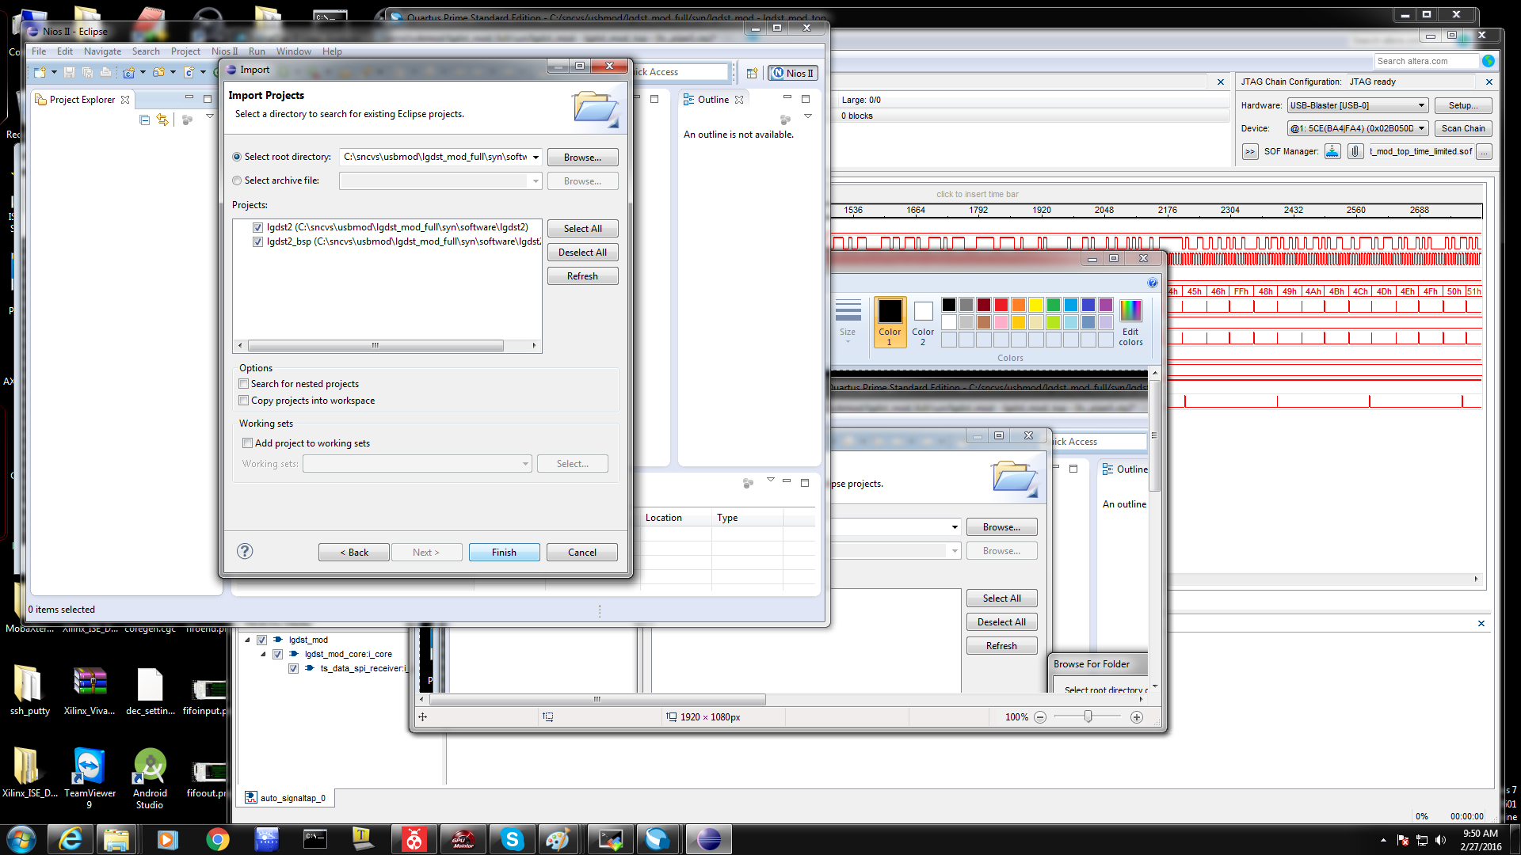

NIOS Launch Step 7 (generate BSP)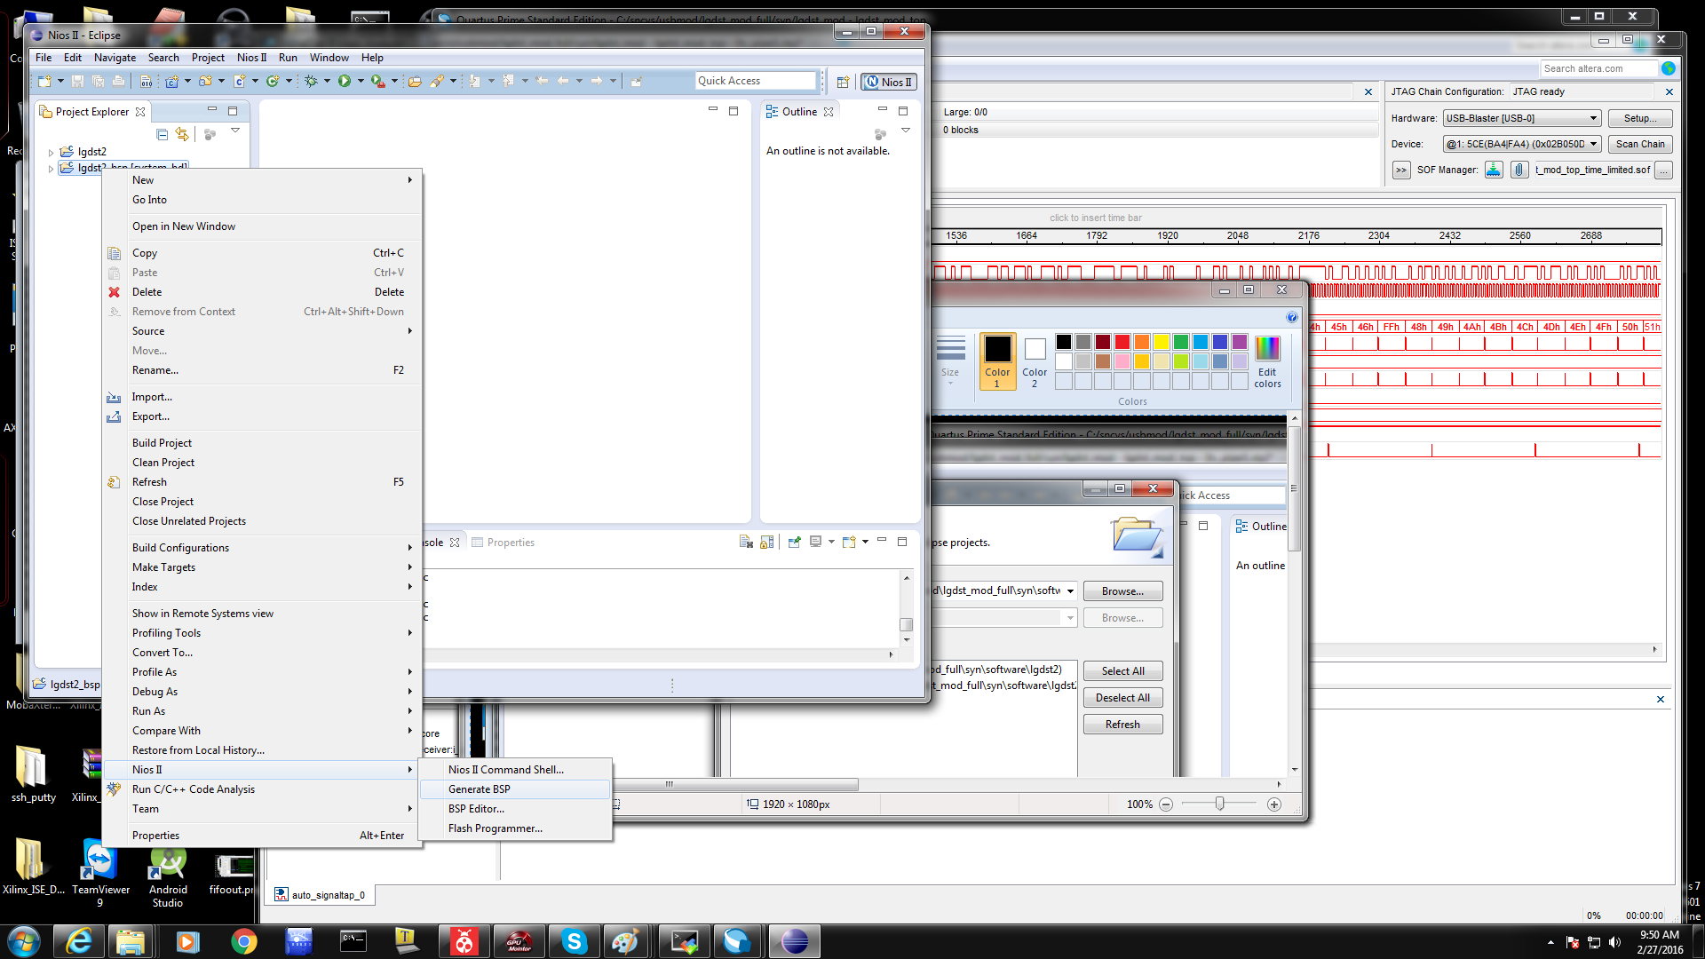

NIOS Launch Step 8 (Generate BSP Results)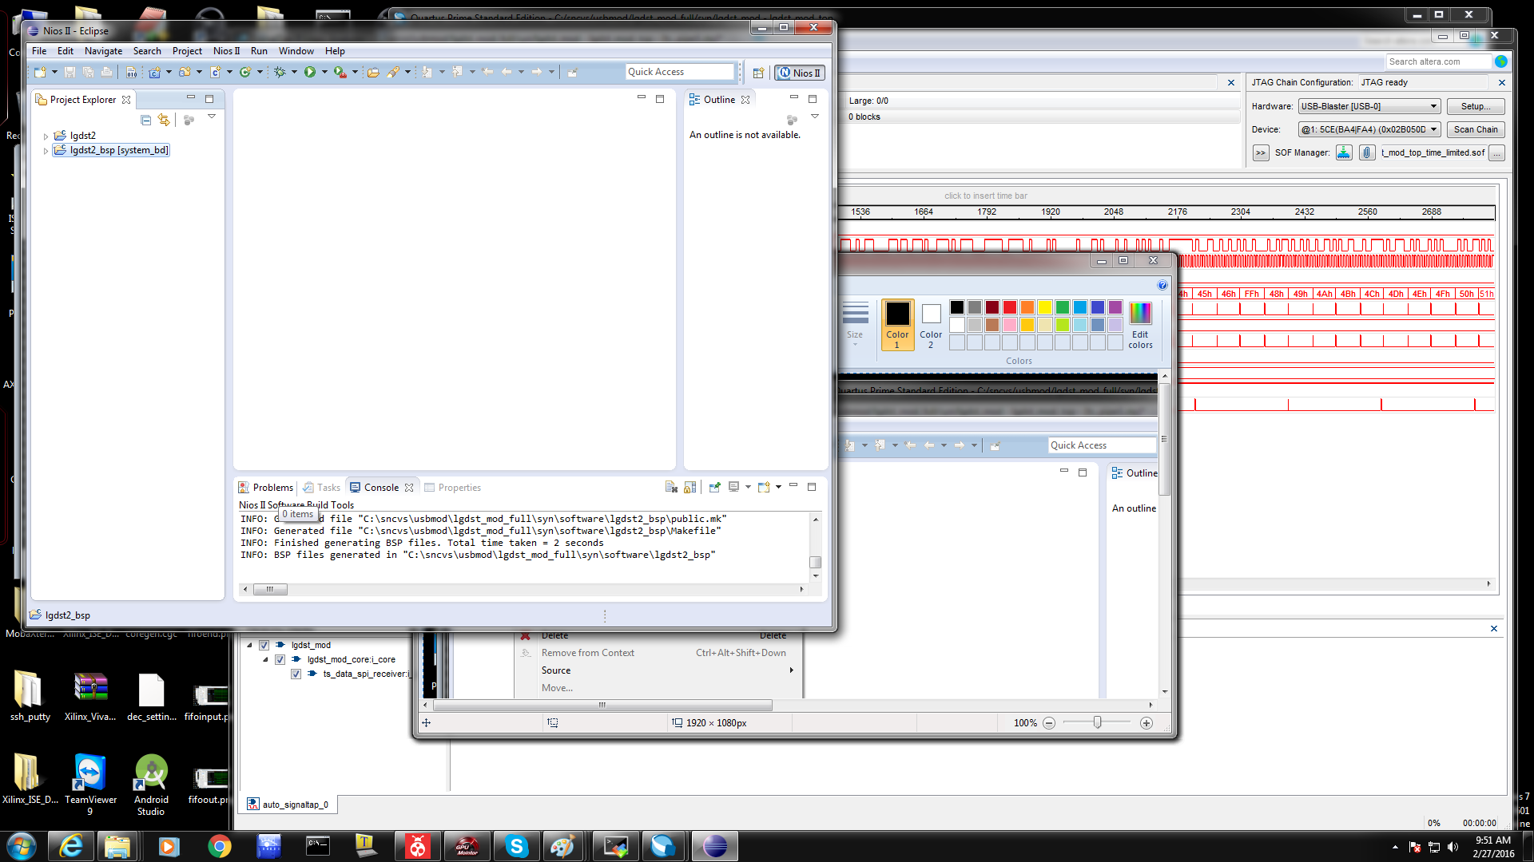

NIOS Launch Step 9 (Application Building)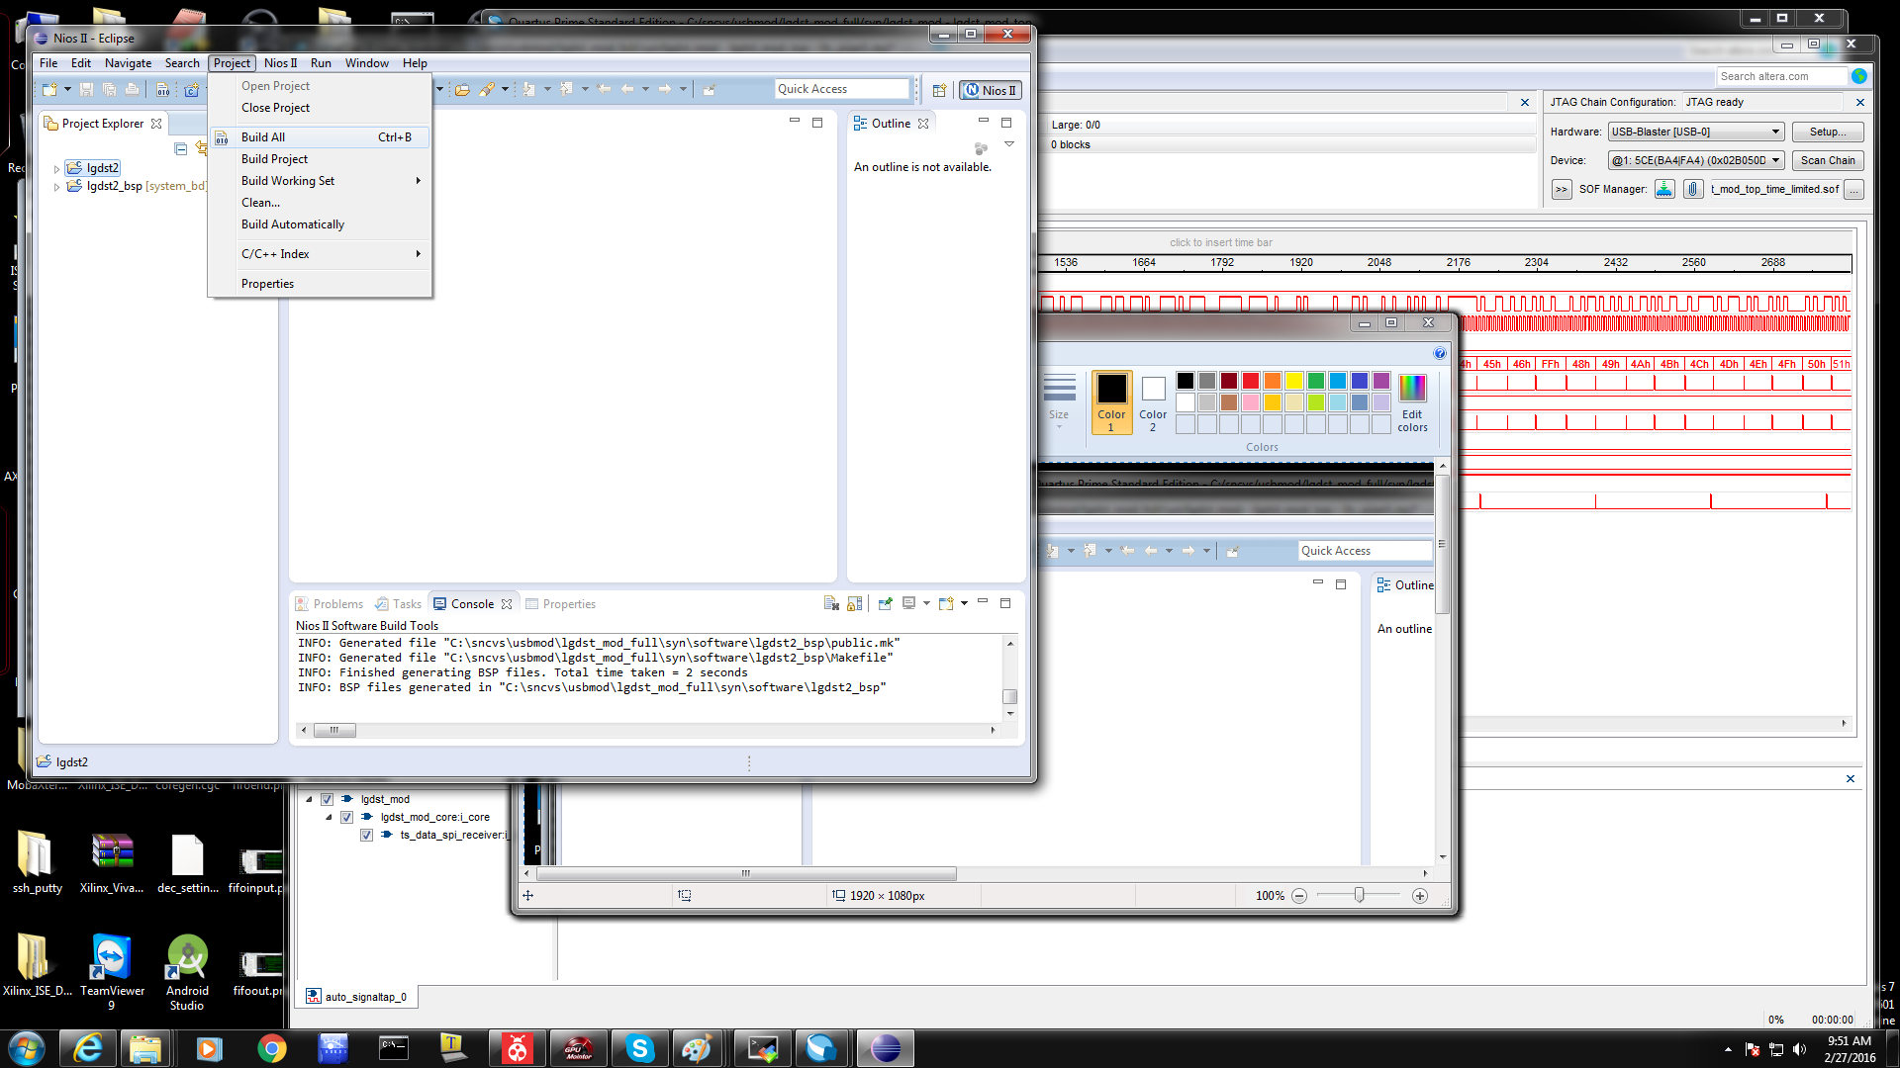

NIOS Launch Step 10 (Application Build Results)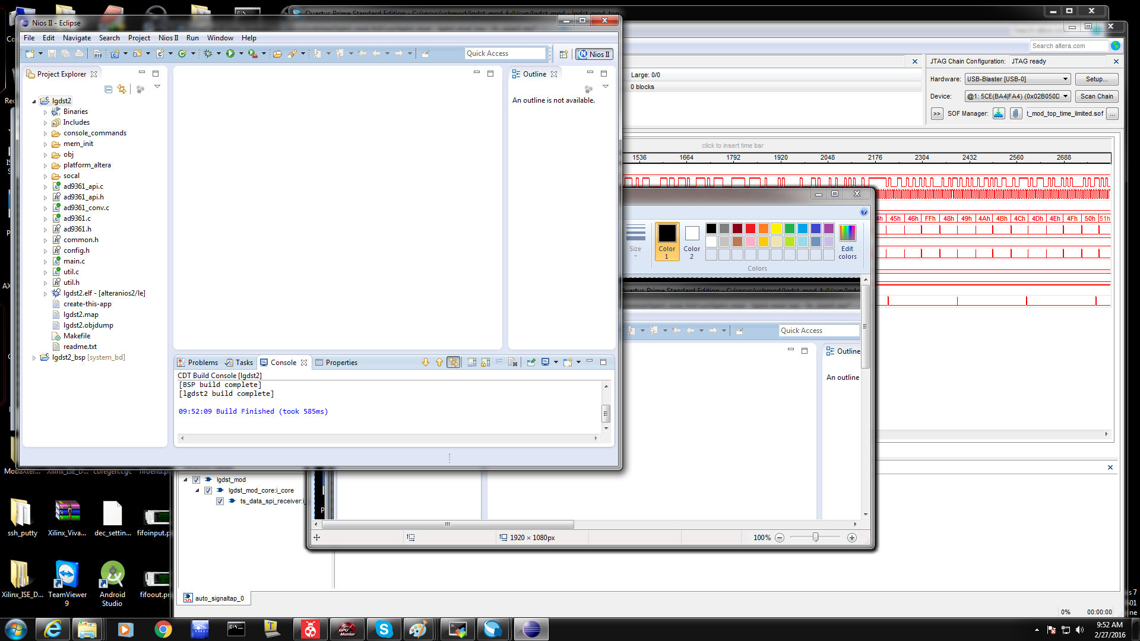

NIOS Launch Step 11 (Application Debug Config)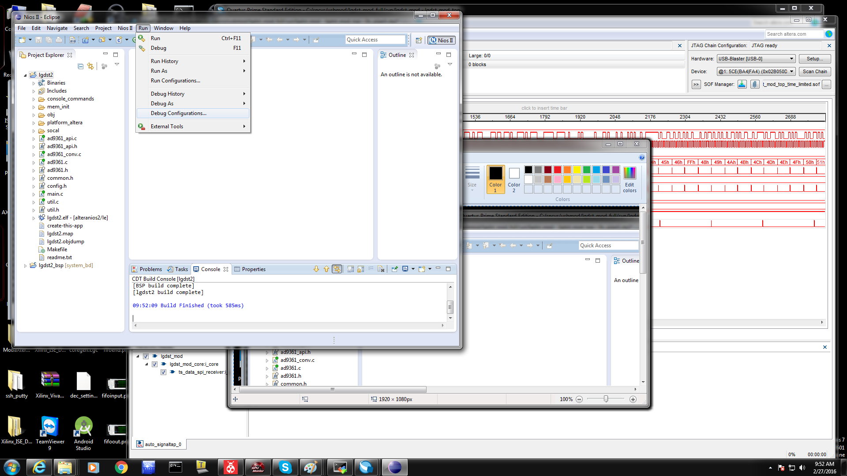

NIOS Launch Step 12 (Generating Application Debug Config, Click NIOS II Harddware)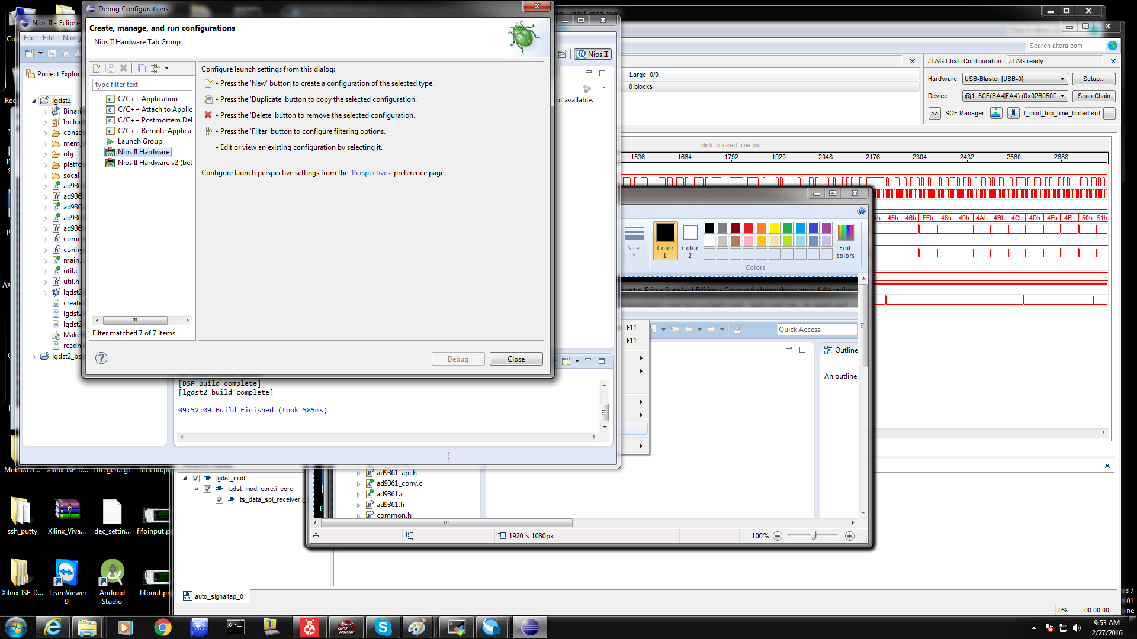

NIOS Launch Step 13 (Verify Nios II Hardware Config Settings - Project)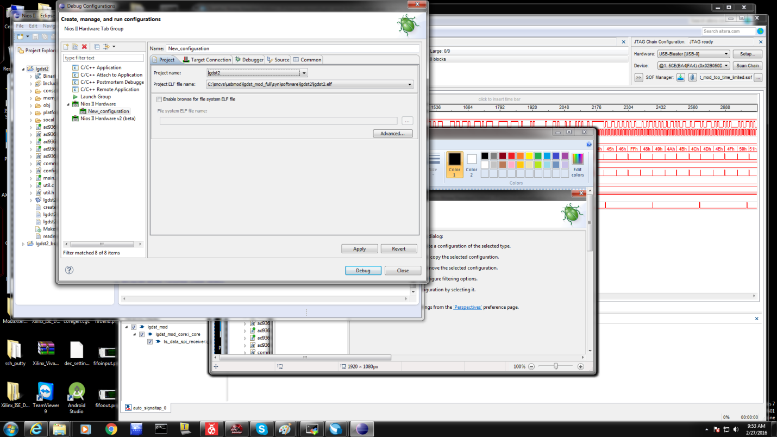

NIOS Launch Step 14 (Verify Nios II Hardware Config Settings - Target Connection)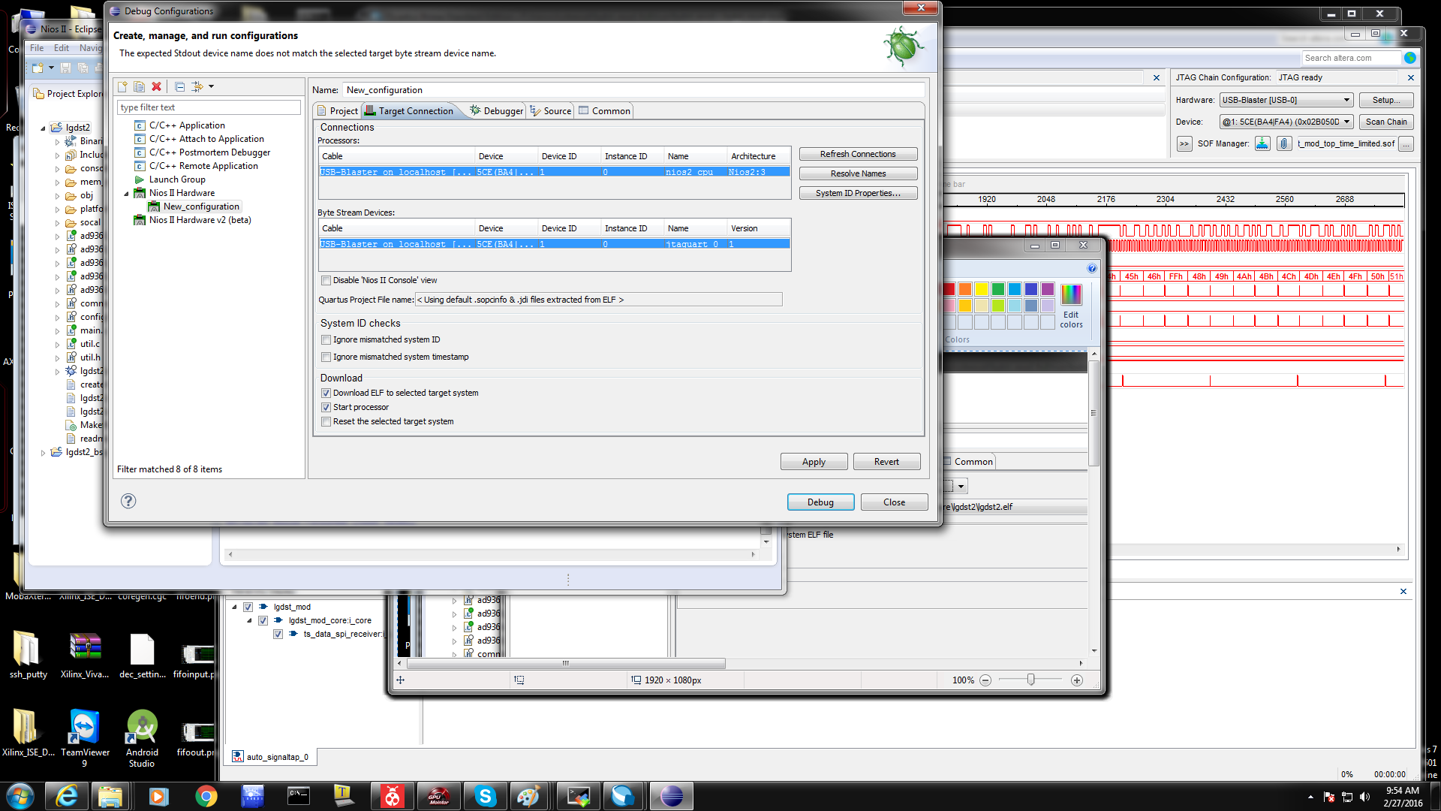

NIOS Launch Step 15 (Verify Nios II Hardware Config Settings - System ID Checks)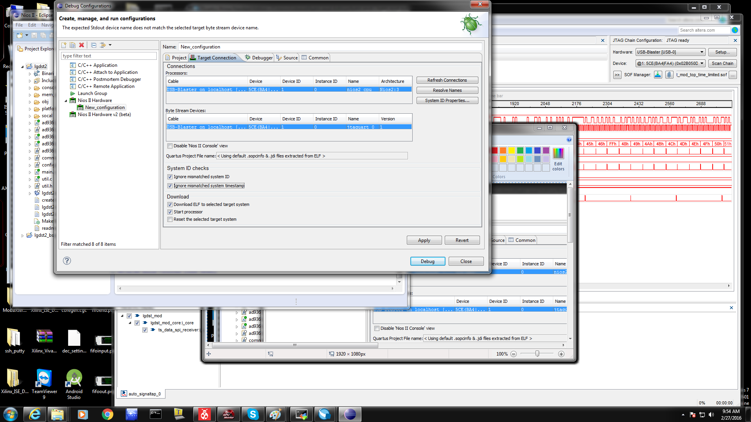

NIOS Launch Step 16 (Verify Nios II Hardware Config Settings - Click Debug)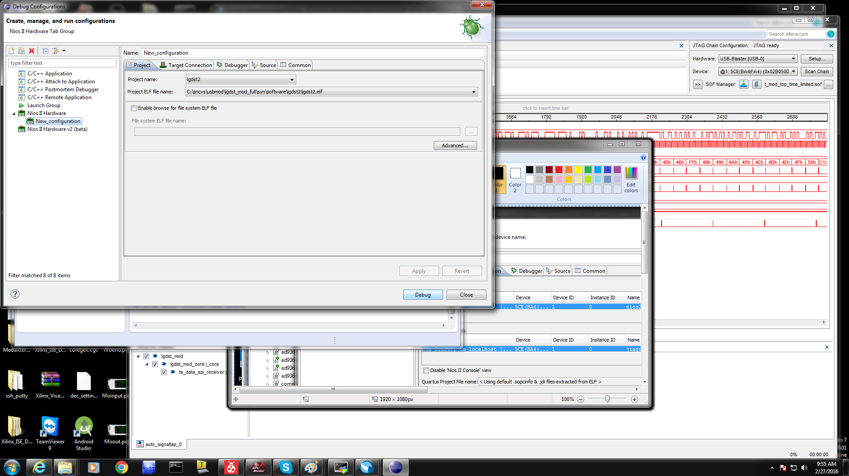

NIOS Launch Step 17 (Switches to Debug Window)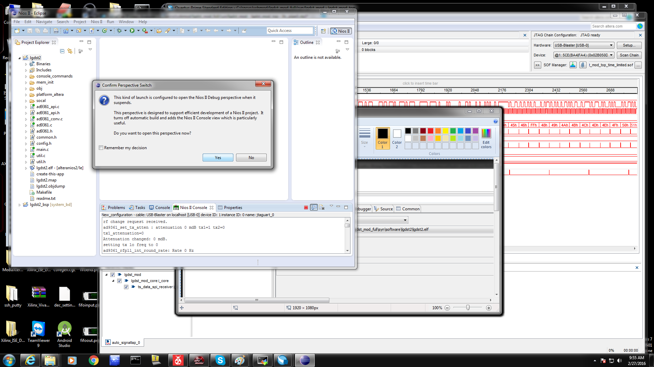

NIOS Launch Step 18 (Click Resume Icon)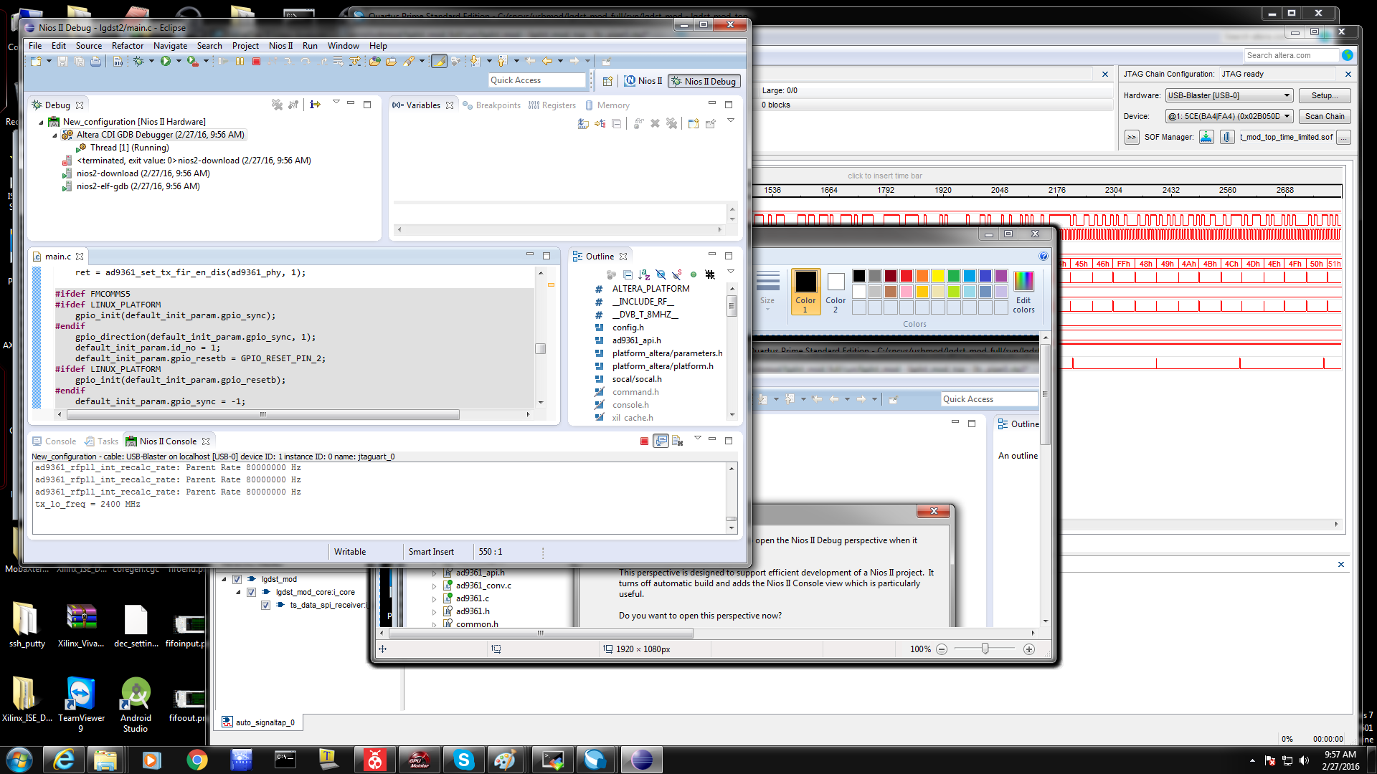

NIOS Launch Step 19 (If break, should be in while(1) loop)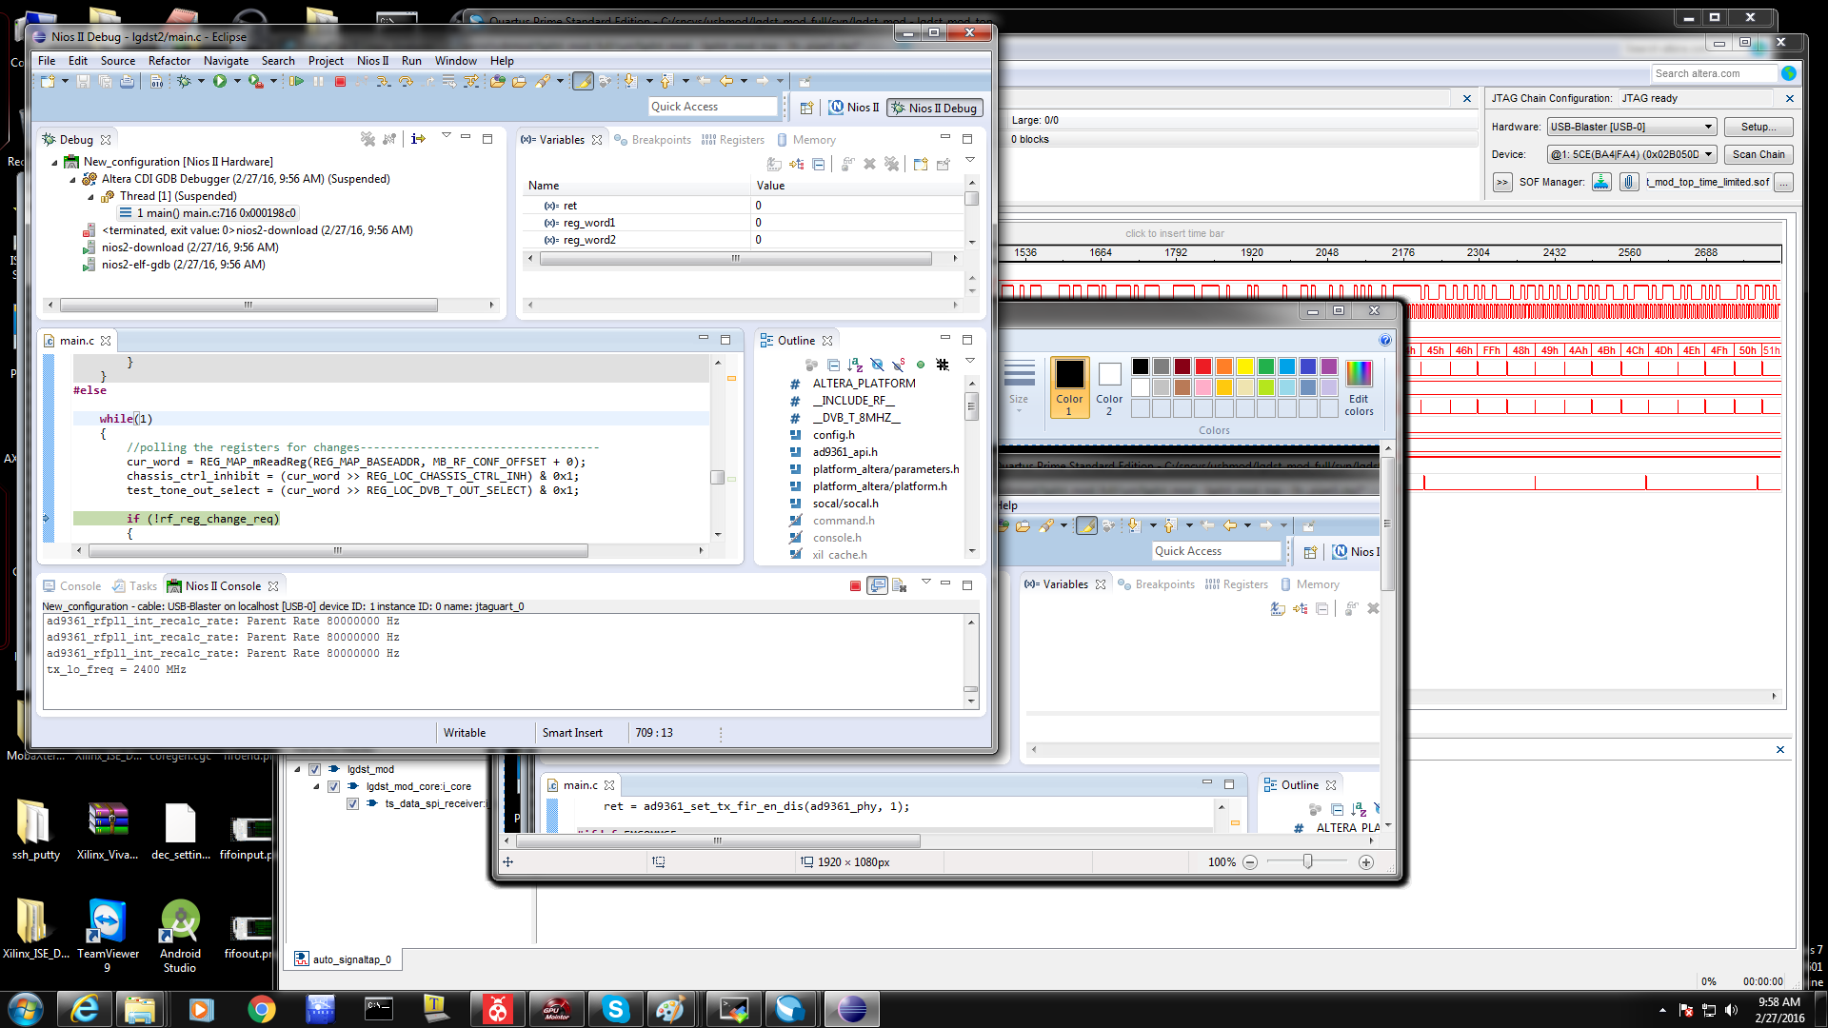

NIOS Launch Step 20 (Restart App without modifications - Click New Configuration)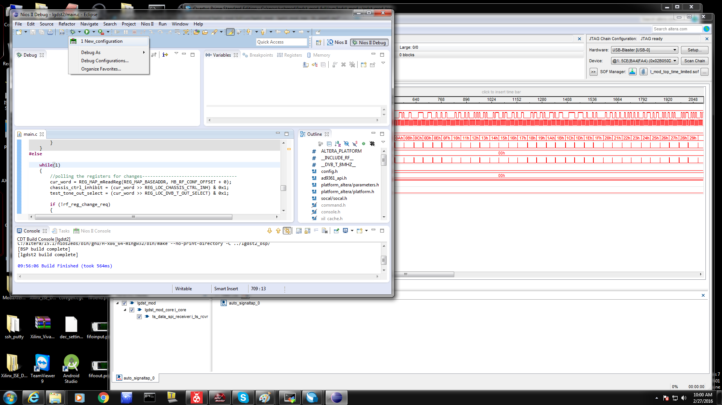

NIOS Launch Step 21 (Bring Up in Quartus Tools-->Qsys to set "Memory Initialization")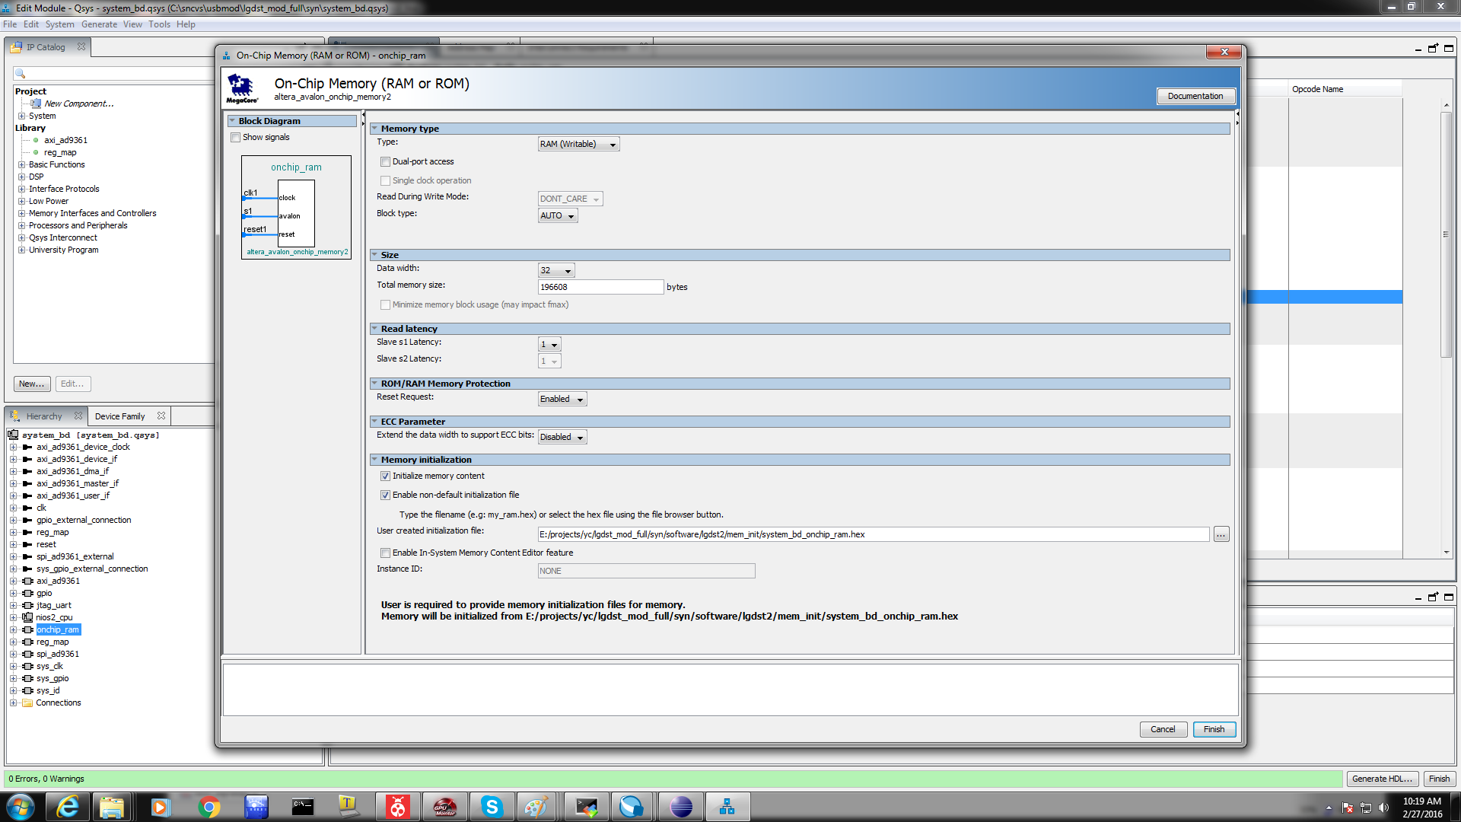

Main.c TX Data Phase Adjustment Params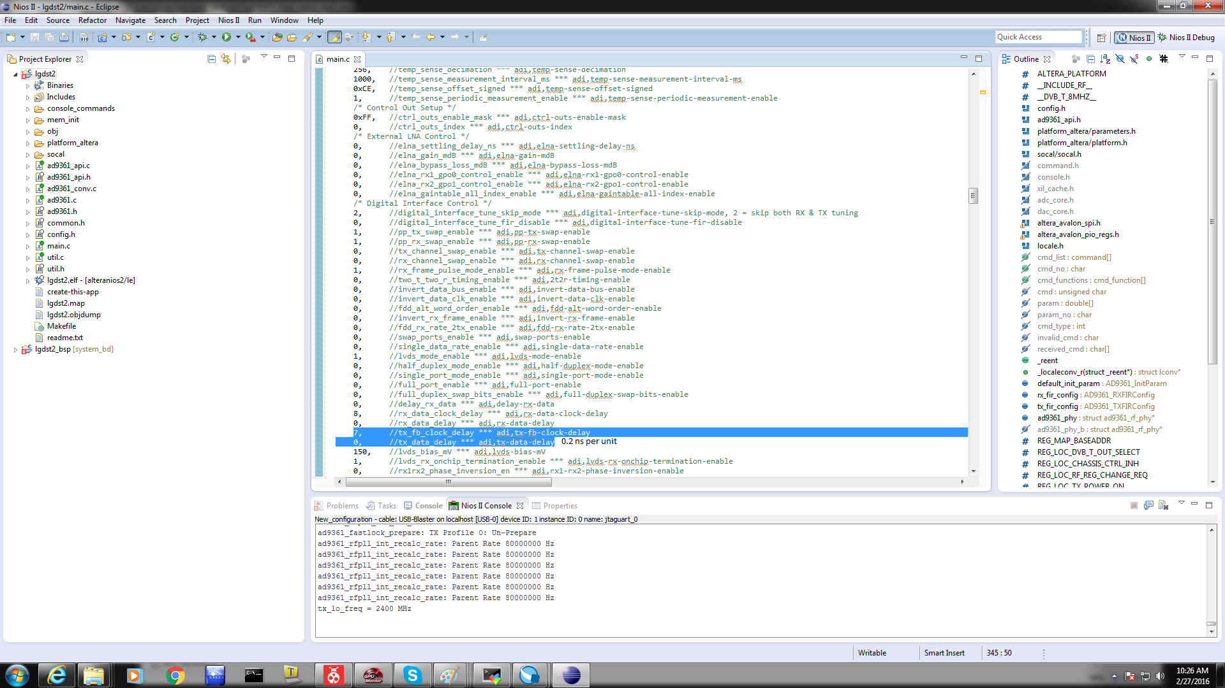

Criticical Parameters in main(void)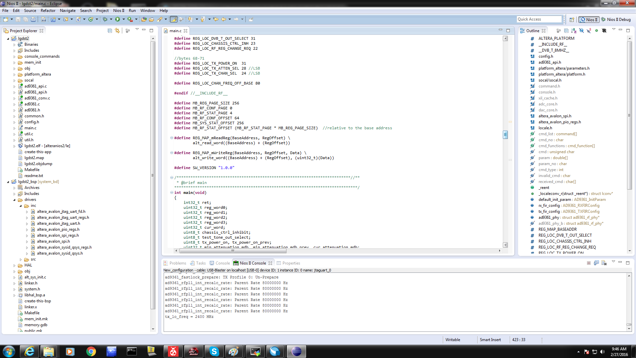

Main.c to configure frequency